

**MAY 30TH & 31ST, 2025**

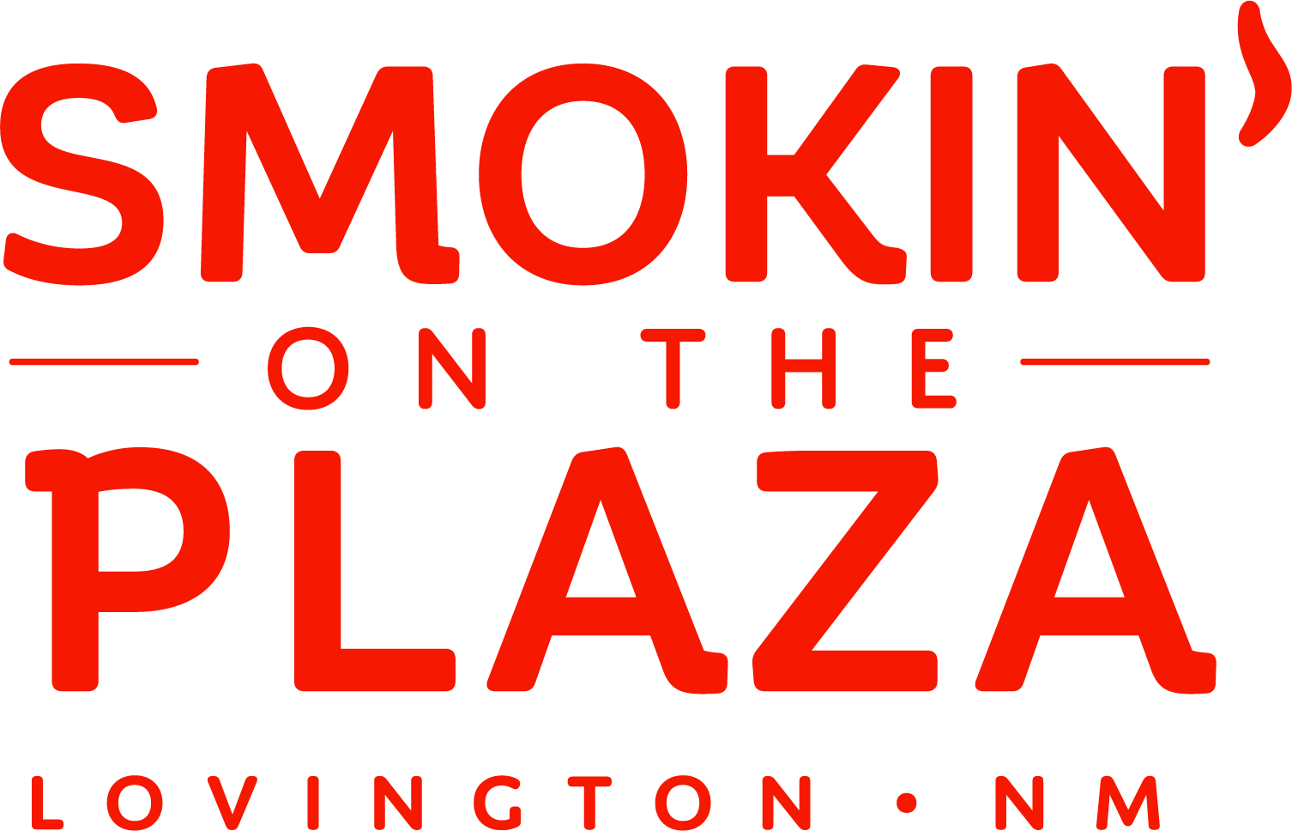Contact Name: Name of Business: Products to be Sold/Menu: Email Address: Phone #: Address: City, State, Zip Code:







 1-4 ($50)

 5-10 ($150)

*Sandbags returned on Saturday, May 31st by 10:00 pm will result in a refund of the fee.

* No water or electricity will be provided.
* Vendors will be contacted by the event manager on **Monday, May 26th with their designated LOAD IN TIME**. Vendors who are late will not be allowed to participate, and fees will not be reimbursed. All vendors must be ready to open at 4:00 pm but are encouraged to open at 12:00 pm for the district employees
* PAYMENT MUST BE RECEIVED WEDNESDAY MAY 28TH by 3:00 pm. Any vendor not paid will lose their spot and

will not be allowed to participate.

* Vendors are not permitted to close the booth until AFTER the Awards Ceremony at 11:00 pm on Saturday, May 31st. Except in case of the vendor being 95% sold out or for any emergency, you must notify the event manager.
* Vendor booths must be completely be fully cleared out by Sunday, June 1st, 8:00 am
* 

